SIMATS ENGINEERING
ASSESSMENT TOOL 2

COURSE NAME: OPERATING SYSTEMS COURSE CODE: CSA04

COURSE OUTCOME COVERED
CO2: Analyze process management and deadlock handling techniques to improve CPU utilization and system performance(BL3-BL4)

QUESTIONS: 5 Total Marks : 100

Annexure A
Scenario based Questions

Code of Conduct:
I KANDALA CHANDANA (192525363) (Name / Reg No) certify that this submission is my original work and that I have adhered to the guidelines specified for this assessment.
I understand that any violation of academic integrity rules will result in disciplinary action.

Signature of the student: Chandana

CONTENTS
- Introduction and Approach
- Q1 – CPU Scheduling in a Real-Time Ticket Booking System
- Q2 – Deadlock in a Banking Transaction Server
- Q3 – Mobile OS App Switching Lag
- Q4 – Deadlock Risk in an Operating System Update
- Q5 – Cloud Server CPU Utilization Analysis
- Summary and Student Declaration

1. INTRODUCTION AND APPROACH
This report answers the five scenario-based questions in the supplied CSA04 Operating Systems Assessment Tool 2. It retains the scenario details and focuses on process scheduling, deadlock handling, mobile app responsiveness, update resource allocation, and cloud CPU utilization.
For each question, the report states the scenario, identifies the operating-system concept, gives a reasoned recommendation, and shows a diagram or calculation where useful. Recommendations are scenario-based; actual scheduling behaviour depends on workload, implementation, and measured performance.

Problem-solving method
- Identify the symptom and the system constraints.
- Apply the relevant OS concept to the given facts.
- Recommend a method and explain why it fits.
- Use an execution order, resource graph, pseudocode, or calculation to support the answer.
- State one limitation and explain how to verify the result.

2. Q1 – CPU SCHEDULING IN A REAL-TIME TICKET BOOKING SYSTEM

2.1 Scenario
The railway ticket booking system experiences heavy load during festival seasons. P1 handles payment gateway transactions (high priority), P2 performs seat availability checks (medium priority), and P3 handles ticket confirmation and printing (low priority). Burst times vary from 2 ms to 20 ms, and customers report that confirmations take too long.

2.2 Recommended algorithm: Priority Scheduling with Aging
Priority scheduling is the most suitable choice among FCFS, SJF, Priority, and Round Robin because the scenario explicitly gives different importance levels to the three process categories. Payment transactions should be serviced promptly, followed by seat checks. However, pure strict-priority scheduling can indefinitely postpone low-priority confirmations. Aging or a bounded-wait policy should therefore be added so that P3 eventually receives CPU time.
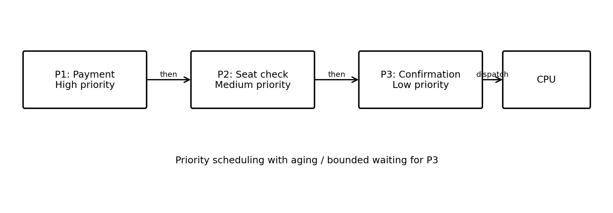
Figure 1. Suggested priority-aware execution flow for ticket booking.

2.3 Sample execution order
Dispatch order | Process | Reason
1 | P1 – Payment | High priority; complete payment processing promptly.
2 | P2 – Seat availability | Medium priority; check seat status after urgent payment work.
3 | P3 – Confirmation/printing | Low priority, but aging or bounded waiting ensures it is not postponed forever.

Illustrative example only: if all three processes are ready at the same time, a simple order is P1 → P2 → P3. Actual order depends on arrival time, CPU burst, preemption, and the aging policy.

2.4 Why it helps
- Important payment work receives CPU time quickly, which is important for transaction flow.
- Seat checks can be serviced before lower-priority printing work when urgent work is waiting.
- Aging prevents P3 from suffering indefinite starvation.
- Priority-aware scheduling can improve perceived responsiveness when priorities accurately represent business urgency.

2.5 Drawback
The main drawback is starvation: if high-priority processes keep arriving, low-priority ticket confirmations may wait too long. Aging, deadlines, or a reserved CPU share can reduce this risk. The system must also ensure that payment processing is not delayed by unbounded work in lower-priority critical sections.

3. Q2 – DEADLOCK IN A BANKING TRANSACTION SERVER

3.1 Scenario
Three transactions use shared resources: T1 transfers money, T2 updates passbook entries, and T3 generates monthly statements. The observed state is T1 holds A and requests B; T2 holds B and requests C; T3 holds C and requests A.

3.2 Resource allocation graph (RAG)
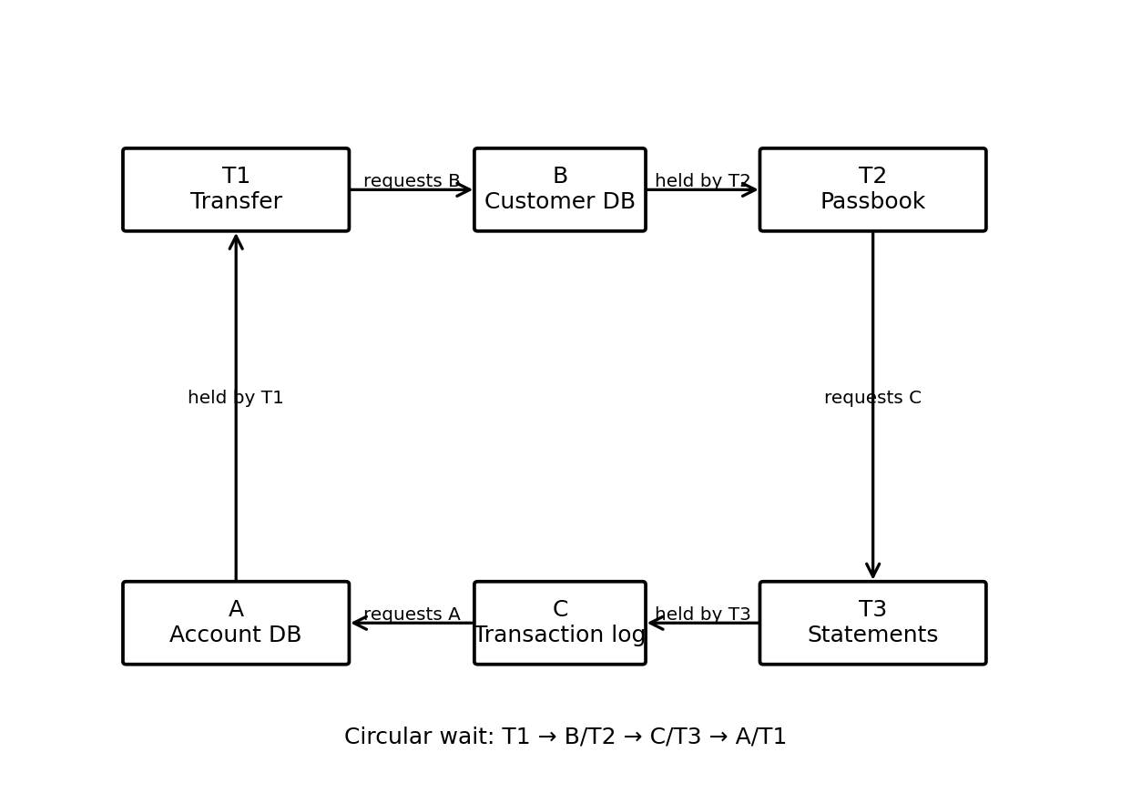
Figure 2. Circular resource-wait relationship in the banking server.

3.3 Has deadlock occurred?
Yes, the stated wait relationships form a circular wait. T1 holds A while waiting for B, which is held by T2. T2 holds B while waiting for C, which is held by T3. T3 holds C while waiting for A, which is held by T1. If each resource is non-shareable and no transaction releases or is forced to relinquish its resource, all three can remain blocked.
Transaction | Currently holds | Waiting for
T1 – Transfer | A: Account Database | B: Customer Info Database
T2 – Passbook | B: Customer Info Database | C: Transaction Logs
T3 – Statements | C: Transaction Logs | A: Account Database

3.4 Recommended technique: Deadlock prevention by lock ordering
Define one global order for all shared resources, for example A → B → C. Every transaction must acquire resources only in that order and release them in reverse order. A transaction needing B and C must not acquire C first and then request B. This prevents circular wait, one of the necessary deadlock conditions.
# Illustrative safe lock-order rule
RESOURCE_ORDER = [A, B, C]

# For any transaction:
needed = sort_resources_by_global_order(resources_needed)
acquire_all(needed)
perform_transaction()
release_in_reverse_order(needed)

3.5 Why not just wait?
Waiting longer does not break the cycle because each transaction is waiting for a resource held by another member of the cycle. A prevention policy changes acquisition order before the cycle can form. Recovery, such as aborting a transaction, is a fallback if a deadlock is detected.

3.6 Verification
- Log resource acquisition and release order.
- Test simultaneous transfers, passbook updates, and statement generation.
- Confirm that all code paths follow the same resource order.
- Check transaction integrity and rollback behaviour if an operation fails.

4. Q3 – MOBILE OS APP SWITCHING LAG

4.1 Scenario
The mobile OS uses Round Robin with a 20 ms time quantum and has 20 background apps active. Opening WhatsApp delays background music, switching between social apps feels laggy, and the CPU shows high idle time despite multiple active apps.

4.2 Why can CPU idle time remain high?
The number of active apps does not guarantee that they are ready to execute. Apps may be blocked waiting for network, storage, timers, or other events. The CPU can be idle if all processes are blocked or if runnable work is constrained by synchronization. Therefore, the first step is to inspect process-state and I/O-wait logs rather than assuming the scheduler alone causes the idle time.
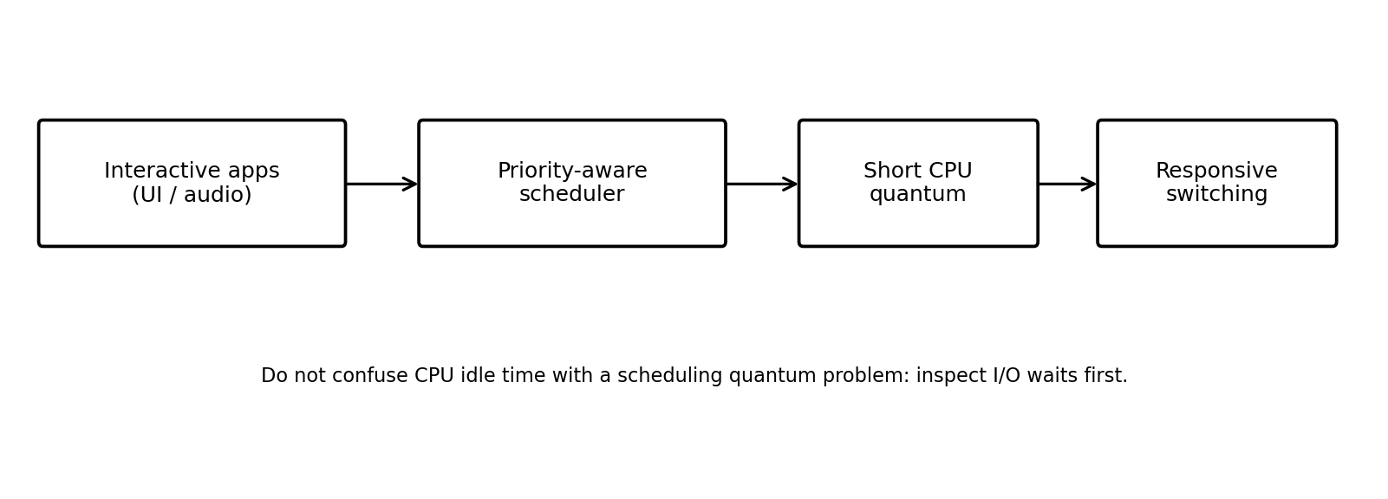
Figure 3. Priority-aware scheduling and responsive app switching concept.

4.3 Is a 20 ms quantum helping or hurting?
A 20 ms quantum can hurt perceived responsiveness for interactive workloads because an app may wait for the current time slice to finish before receiving CPU time. However, a larger quantum reduces scheduling overhead. The best value depends on device hardware and workload; the scenario does not provide enough measurements to claim one universally optimal quantum.

4.4 Recommendation
Use a mobile-oriented preemptive priority scheduler that favours foreground interactive tasks and time-sensitive audio, while still allowing background tasks to progress. Test a shorter quantum (for example, 5–10 ms) for responsive tasks and measure context-switch overhead. This range is a tuning proposal, not a guaranteed optimum.

4.5 How it improves performance
- Foreground apps receive CPU service sooner, reducing visible touch and switching delays.
- Time-sensitive audio receives suitable priority to reduce interruptions.
- A shorter tested quantum can improve responsiveness by allowing more frequent scheduling opportunities.
- Investigating I/O waits addresses CPU idleness that scheduling changes alone cannot fix.

4.6 Limitation
A very short quantum can increase context switches and reduce useful CPU time. The scheduler should be benchmarked using app-switch latency, audio interruptions, CPU utilisation, context switches per second, and background-task completion time.

5. Q4 – DEADLOCK RISK IN AN OPERATING SYSTEM UPDATE

5.1 Scenario
During an OS update, M1 copies update files, M2 installs drivers, M3 updates the registry, and M4 validates system integrity. The logs show M1 holds disk I/O R1 and waits for kernel lock R2; M2 holds R2 and waits for configuration lock R3; M3 holds R3 and waits for R1.

5.2 Circular wait
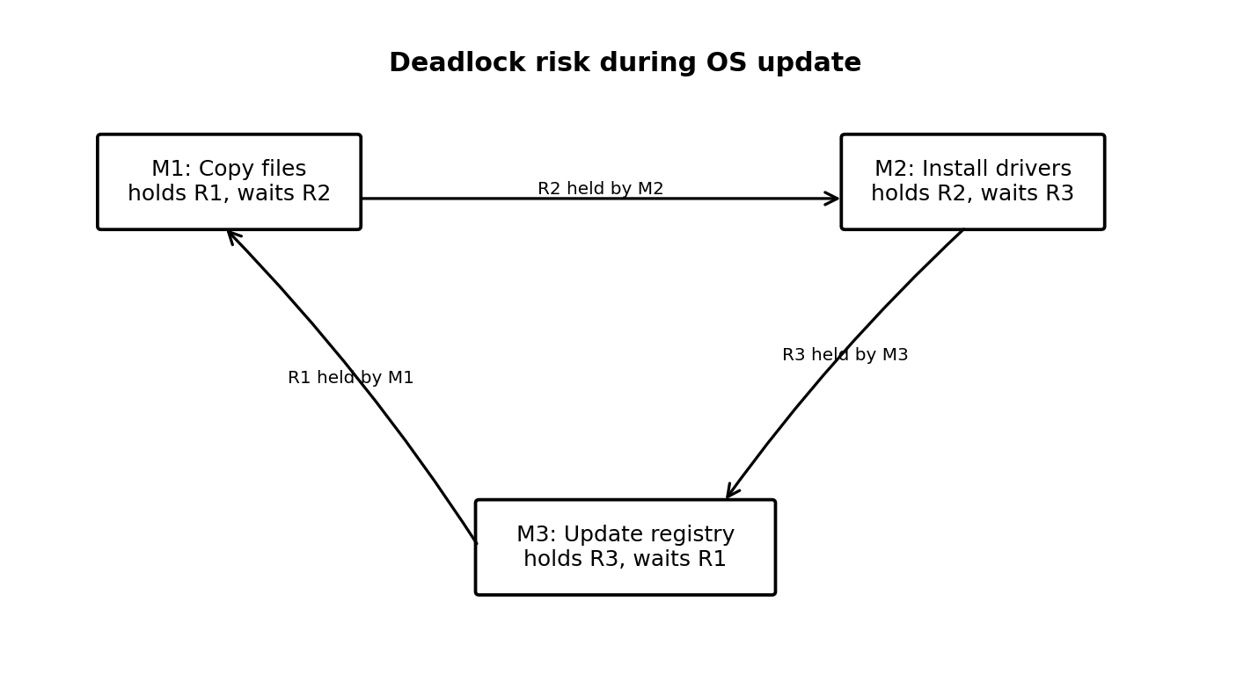
Figure 4. Resource cycle that can cause an update deadlock.
The cycle is M1 → R2 (held by M2) → M2 → R3 (held by M3) → M3 → R1 (held by M1). This can cause deadlock if the resources are exclusive and none of the modules releases its held resource while waiting.

5.3 Banker’s algorithm-style avoidance
Before granting a resource request, the OS maintains the available resources, each module's current allocation, and its declared maximum need. It tentatively grants the request only if the resulting state is safe—that is, there is some order in which all modules can finish and release resources. The scenario does not provide numerical resource instances or maximum-need vectors, so a numerical Banker’s calculation cannot be completed from the supplied information.
# Banker-style safety check (illustrative pseudocode)
if request <= need[module] and request <= available:
tentatively_allocate(module, request)
if safe_state_exists(available, allocation, need):
grant_request()
else:
undo_tentative_allocation()
make_module_wait()
else:
make_module_wait()

5.4 Prioritizing modules
Prioritize modules according to dependencies and criticality rather than running all modules at maximum priority. Ensure prerequisite file-copy and validation steps have the resources they need, avoid holding kernel/configuration locks during slow disk I/O, and schedule CPU-intensive validation so it does not unnecessarily delay essential update operations. Priority alone does not eliminate deadlock; safe resource allocation and consistent lock ordering are still needed.

5.5 Suggested design controls
- Use a consistent lock ordering for R1, R2, and R3 wherever feasible.
- Request resources in short, well-defined sections and release them promptly.
- Use Banker-style safety checks if maximum resource needs can be declared reliably.
- Log wait-for relationships and provide timeout/recovery handling for detected deadlocks.

6. Q5 – CLOUD SERVER CPU UTILIZATION ANALYSIS

6.1 Scenario
The cloud provider reports that VM processes wait for network or disk 80% of the time and use the CPU 20% of the time. Each physical server runs 7 VMs.
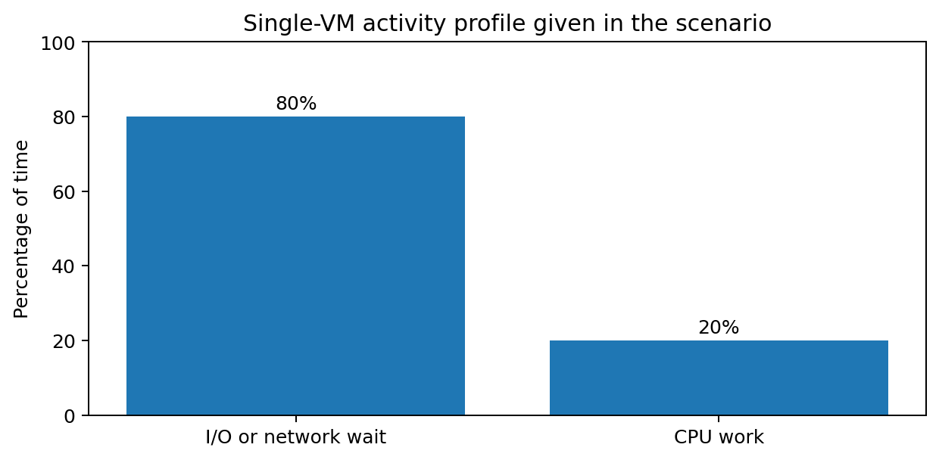
Figure 5. Activity split stated for the VM workload.

6.2 Calculation
The classic multiprogramming estimate is U = 1 − pⁿ, where p is the probability that one process is waiting for I/O and n is the number of independent processes. Using the scenario's p = 0.8 and n = 7 VMs:
p = 0.80
n = 7
U = 1 - (p ** n)
= 1 - (0.8 ** 7)
= 1 - 0.2097152
= 0.7902848

Estimated CPU utilization ≈ 79.03%

This estimate assumes independent I/O-wait behaviour and that a runnable VM can use the CPU when another VM waits. The source document's equation rendering is not visible in the extracted text, so this is the standard classic formula consistent with the stated p and number of VMs. If the lecturer supplied a different formula, use that version.

6.3 Interpretation
The given 20% CPU time describes an individual VM's reported activity profile. The 79.03% figure is the classic estimate for aggregate CPU utilization when 7 independent processes/VMs overlap their I/O waits. These are different interpretations and should not be treated as the same measurement. Actual server utilization must be measured from host-level metrics.

6.4 Effect of changing the number of VMs
VM count n | Estimate U = 1 − 0.8ⁿ | Interpretation
1 | 20.00% | One VM often waits for I/O.
3 | 48.80% | Other VMs can use CPU during waits.
5 | 67.23% | More overlap can improve utilization.
7 | 79.03% | Estimated utilization rises further.
10 | 89.26% | Potentially higher use, if resources are available.

Increasing the VM count can improve throughput when the server has spare CPU and memory and VM waits are independent. Beyond the host's capacity, extra VMs can cause CPU contention, memory pressure, storage/network congestion, and lower per-VM performance. Reducing VM count can help if the host is overloaded, but may leave CPU idle if too few workloads are runnable.

6.5 Two OS-level strategies
- Improve I/O efficiency: use suitable buffering, asynchronous I/O, batching, and storage/network performance monitoring to reduce unnecessary wait time.
- Right-size and schedule VMs: use host scheduling and resource limits based on measured CPU, memory, and I/O demand. Consolidate lightly loaded VMs where safe, while avoiding overcommitment.

6.6 Metrics to monitor
- Host CPU utilization and run-queue length.
- Per-VM CPU ready/wait time and memory pressure.
- Disk latency, network latency, and I/O queue depth.
- Application throughput and response time before and after changing VM count.

7. OVERALL SUMMARY
Question | Main concept | Recommendation
Q1 | CPU scheduling | Priority scheduling with aging/bounded waiting.
Q2 | Deadlock in banking | Prevent circular wait with global lock order A → B → C.
Q3 | Mobile responsiveness | Priority-aware preemptive scheduling; benchmark shorter quantum and inspect I/O waits.
Q4 | Update deadlock risk | Banker-style safe-state checks plus consistent lock ordering.
Q5 | Cloud CPU utilization | Classic estimate 79.03% for 7 independent VMs with p = 0.8; optimize I/O and right-size VM count.

CONCLUSION
The scenarios show that Operating Systems performance depends on both scheduling decisions and resource management. Priority scheduling can improve service for urgent ticket operations but needs aging to protect low-priority work. A consistent resource order prevents circular wait in banking transactions. Mobile app lag requires analysis of runnable processes and I/O waits as well as scheduler tuning. OS updates should use safe resource allocation, and cloud VM consolidation should be guided by measured host-level utilization. Calculations and design changes should always be validated against actual system behaviour.

RUBRICS FOR CALCULATION- Scenario based assessment
Criteria | Weightage (%) | Level 4 (Exemplary) | Level 3 (Proficient) | Level 2 (Developing) | Level 1 (Beginning)
Understanding of Scenario | 20% | Demonstrates clear and complete understanding of the scenario and context | Shows good understanding with minor gaps | Partial understanding; misses key aspects | Misinterprets or fails to understand the scenario
Identification of Key Issues | 20% | Accurately identifies all relevant issues and factors involved | Identifies most key issues with minor omissions | Identifies limited issues; some irrelevant points | Unable to identify key issues
Application of Concepts | 25% | Applies appropriate concepts effectively to address the scenario | Applies concepts with minor errors | Limited or partially correct application | Unable to apply relevant concepts
Decision Making | 20% | Makes well-reasoned, logical decisions with strong rationale | Makes reasonable decisions with some justification | Makes weak decisions with limited justification | No clear decisions made or rationale provided
Clarity of Response | 15% | Response is clear, structured, and logically presented | Generally clear with minor issues | Somewhat unclear or poorly structured | Disorganized and difficult to understand

TOTAL MARKS AWARDED FACULTY SIGNATURE

